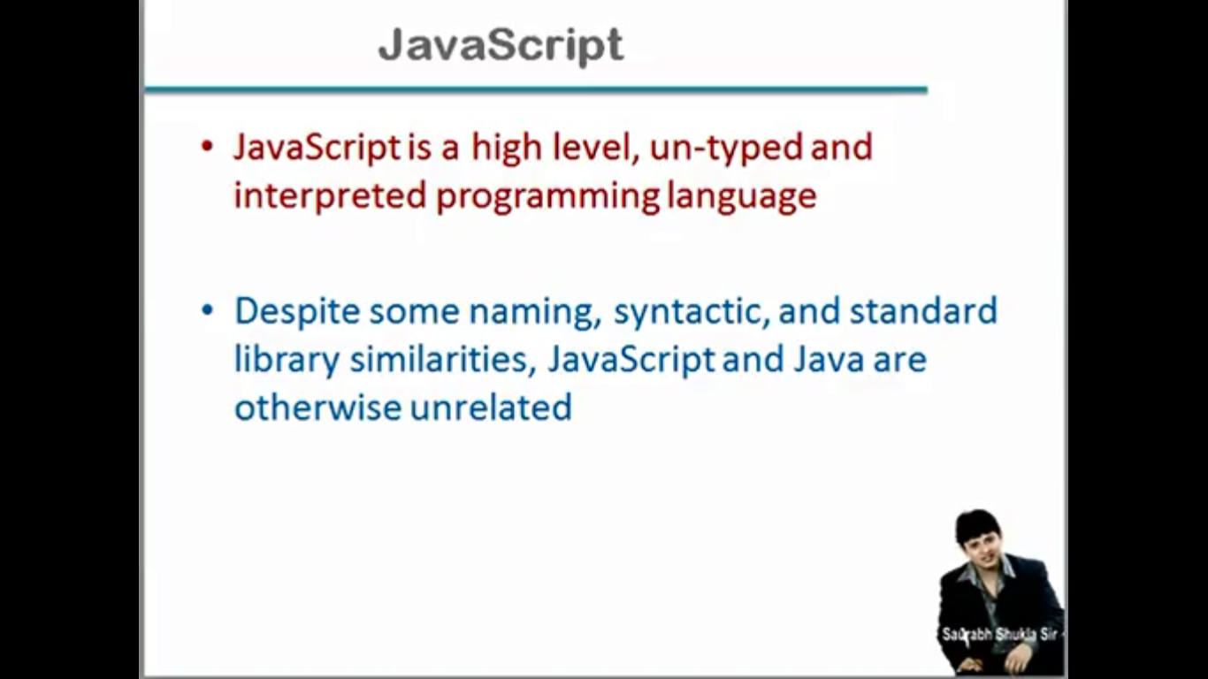

Complier:- compiler pahale hamare program ko ek intermediate formate mai convert karta h or bad mai hum ush program ko run kar sakte h.

Interpreted:-koyi beech mai intermediate formate nahi hota hai jab bhi code ko run karna hota h ushi bakt code machine formate mai translate hota h. koyi intermediate file nahi banti hai jab hum interpreted ka use karate h.

Un-typed:-java script mai koyi data type nahi hote. Programer ko koyi data type provide nahi kiya jata. int char float nahi hota,

Low level language machine dependent language hoti hai

High level langyage machine independent language hoti hai.

Java script high level language hai bo kisi bhi machine par use kar sakte hai.

Javascript ek light weight (kam resource use karne bali language hai), jishko hum web application banate time use karate hai.

What is JavaScript ?

JavaScript is a light-weight, open-source, client-side scripting language developed by NETSCAPE IN 1995.

PNINFOSYS

